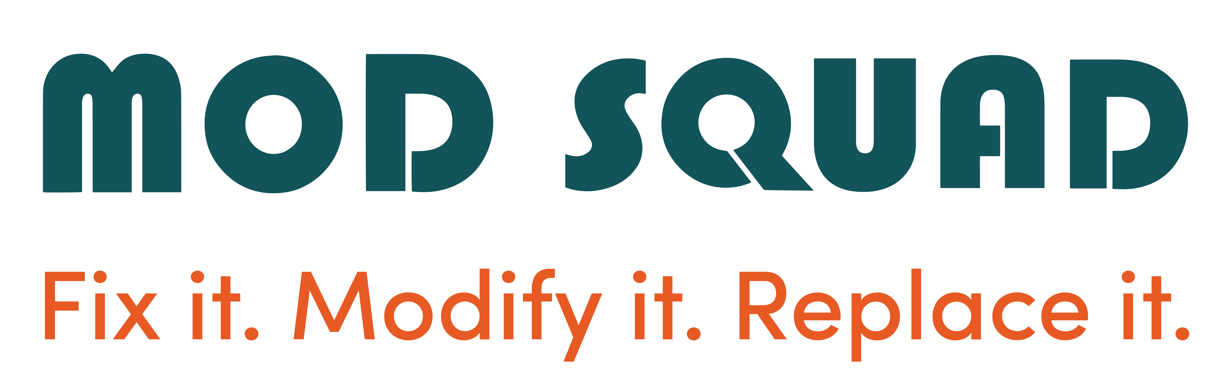

RT CENTRAL OHIO LAUNCHES SOCIAL ENTERPRISE, MOD SQUAD

Columbus, Ohio – August 17, 2018 – RT Central Ohio is proud to launch Mod Squad, a thoughtfully designed social enterprise serving as Central Ohio’s one-stop shop for handyman services.

“Through our commitment to helping people maintain safe housing, we’ve found there is a real need for a local source of qualified, trusted home maintenance pros,” said Julie Smith, Executive Director. “This led to the launch of Mod Squad.”

“Mod Squad is for everyone,” Smith continued. “Whether you’re a young pro with better things to do, a parent with too much to do, or the DIY scene is just not for you, Mod Squad can help – and, there’s no job too small.”

Mod Squad can fix it, modify it, or replace it with a trusted team of experienced, bonded and insured pros. The results are impressive, and proceeds provide funding for home repairs for vulnerable low-income senior and disabled homeowners.

“From a leaky faucet or broken light switch, to installation of grab bars, closet organizers, shelving, or ceiling fans, Mod Squad can help,” Smith continued. “Our team can customize services to meet your unique needs, style and budget.”

Make your home more beautiful, more comfortable and more functional with Mod Squad. Call Julie Smith at 614-258-6392 to discuss your project.

Special thanks to Columbus City Council in partnership with The Ohio State, Social Ventures Columbus, and The Columbus Foundation and The Buzz Maker Public Relations for their steadfast support.

About RT Central Ohio
Established in 1991 and located in Columbus, RT Central Ohio is a 501(c)3 nonprofit committed to improving homes and neighborhoods. The organization provides specialized programs and services that help sustain safe housing, while serving vulnerable senior and disabled homeowners.

