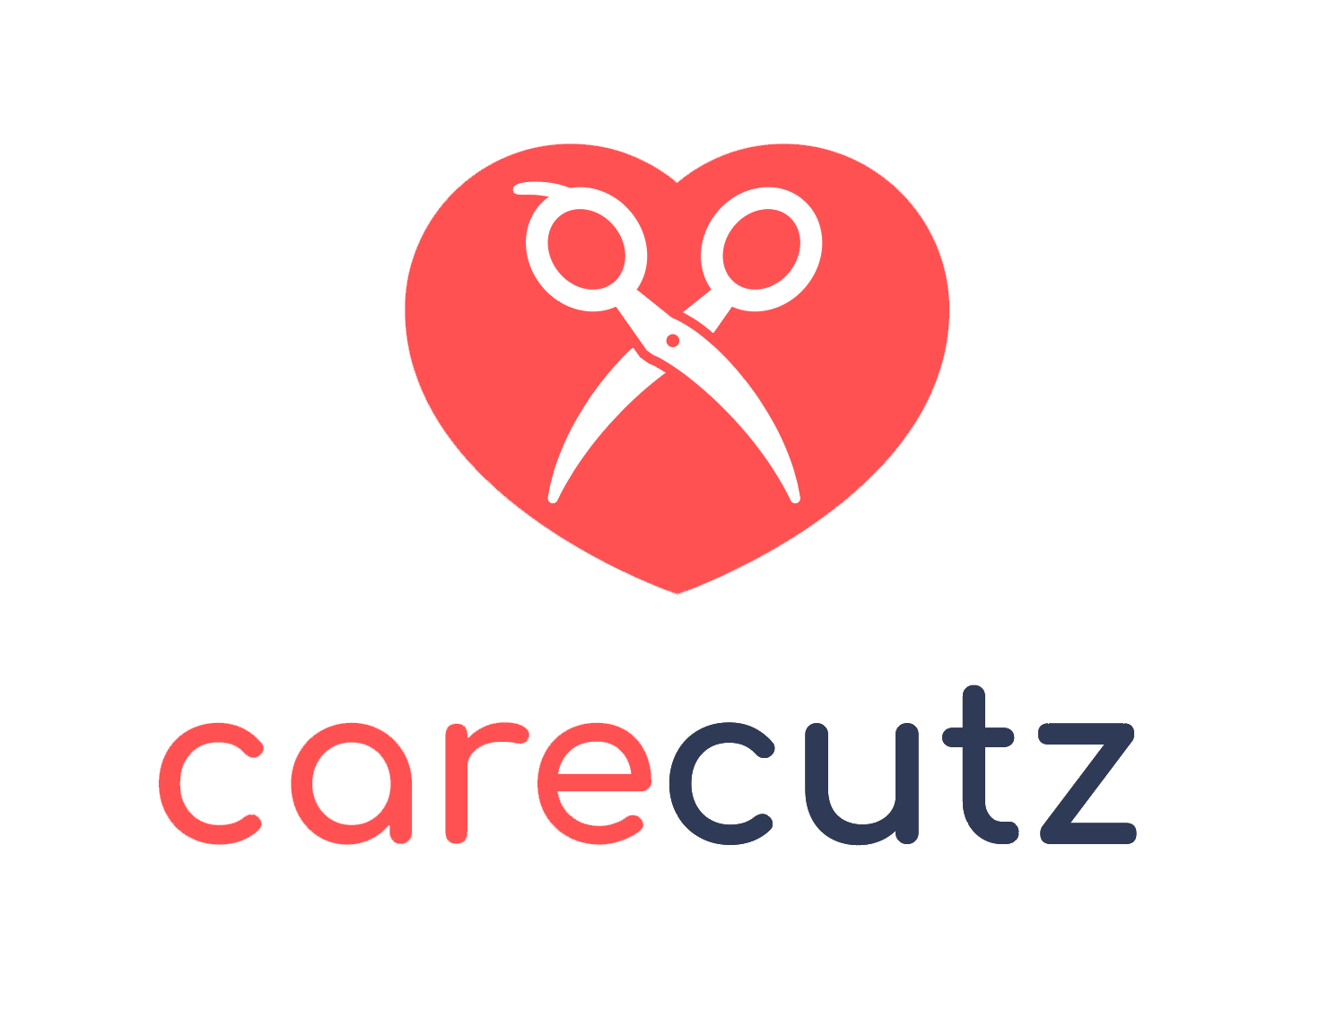

CareCutz Rolls Out New Website and Brand Refresh

Columbus, Ohio – March 6, 2019 – Social enterprise CareCutz today announced the launch of its newly designed website with a freshly branded look, robust content and seamless functionality.

The CareCutz mission is to connect Ohio’s disabled with specially trained salon professionals while raising awareness for those with unique needs and abilities.

Co-founders Marvin Green and Sean Black now showcase the CareCutz concept and the company’s social impact via the new website as they await the completion of the highly anticipated CareCutz app, coming soon.

“An average of 14.1 percent of Ohioans are challenged by a disability,” said Green. “That’s about 1.6 million people in our state. There are many inspirational people that make up this group, and the CareCutz mission is to better serve them. Our new website serves as an important milestone to help us accomplish that.”

To position the organization for growth, the team partnered with Goodwill Columbus in 2017 to develop a pilot training program for salon pros. By 2018, after nearly 10 years in the field, CareCutz had documented more than 16,000 salon services provided to more than 3,000 special-needs individuals.

In 2018, CareCutz was selected among 13 companies to participate in the new Social Impact Validation Pilot Program supported by the Better Business Bureau of Central Ohio and SocialVentures of Columbus in cooperation with Measurement Resources Company. The pilot program will further advance a shared mission to help consumers find charitable organizations they can trust. CareCutz is also supported by OCALI, an organization dedicated to improving access and opportunities for those with disabilities via research and informed public policy.

About CareCutz
Co-founded in 2009 by Marvin Green and Sean Black, CareCutz is a social enterprise dedicated to connecting the disabled with specially trained salon professionals. The mission is to put high-quality salon services within reach for the differently abled, while providing special training and certification programs for salon professionals. CareCutz seeks to empower the disabled, and create positive social and economic impact. Visit www.CareCutz.com and connect via Facebook, Twitter and Instagram @CareCutz.

